A 1987 study compared the speeds at which two lizard species (Sagebrush lizards and Western fence lizards) could complete a maze. The speeds, in meters per second, to complete a maze was recorded for 26 Sagebrush lizards and 22 Western fence lizards.

The data are below. You may either copy and paste the data lines of code below or download and open the lizards.R script on Canvas to bring this data into R. You do not need to import a csv file for this week’s assignment. Run both the Sagebrush and Western_fence lines to store the vectors of speeds in R.

Sagebrush <- c(1.74, 1.41, 1.30, 1.42, 2.23, 1.67, 1.15, 1.38, 1.75, 1.47,

1.59, 1.99, 2.21, 1.41, 1.70, 1.89, 1.80, 2.02, 1.87, 1.75,

1.15, 1.63, 1.84, 1.20, 1.28, 1.08)

Western_fence <- c(1.52, 1.74, 1.79, 2.01, 3.13, 2.89, 2.56, 2.65, 3.38, 2.36,

2.21, 1.65, 2.05, 2.84, 3.36, 2.02, 1.63, 2.51, 2.18, 2.09,

1.82, 2.53)

1. (1 point) In this assignment you’ll estimate and test the difference in the average speeds of the two lizard species to complete the maze. Write a question of interest for which a *two-sided* *t* test for the difference in populations means can be used to answer.

**Are the average speeds of the two species different?**

1. Compute summary statistics for each sample.
   1. (1.5 points) Report the sample mean, sample standard deviation, and sample size for the sampled maze speeds of Sagebrush lizards. *Hint: use the mean(), sd(), and length() functions in R to do this.*

­

* 1. (1.5 points) Report the sample mean, sample standard deviation, and sample size for the sampled maze speeds of Western fence lizards. *Hint: use the mean(), sd(), and length() functions in R to do this.*

$${\overline{x}}_{W}=2.315$$

$$s_{W}=0.555$$

$$n_{W}=22$$

1. (1 point) The parameter of interest is the difference in the population means of maze speeds for Sagebrush and Western fence lizards, $μ_{S}-μ_{W}$. Using the sampled data, calculate the point estimate for this parameter of interest.

Point estimate = ${\overline{x}}_{S}-{\overline{x}}_{w}=1.613-2.315=-0.702$

1. (1 point) The point estimate in the previous problem has an associated estimate for the standard error. Calculate this standard error estimate and report the value below.

Standard Error = $\sqrt{\frac{{(0.324)}^{2}}{26}+\frac{{(0.555)}^{2}}{22}}=0.134$

1. (1 point) The point estimate reported in question 3 also has an associated degrees of freedom. Using one of the two tools provided in the Week 8 module on Canvas for calculating Satterthwaite degrees of freedom, calculate the degrees of freedom.

**Using Desmos:**

1. (2 points) Construct a 90% confidence interval for the difference in the average maze speeds of the two lizard species. Report the numerical values for the lower and upper bounds of the interval. Show your work.

$$t^{*}=qt\left(0.95, 32.582\right)=1.693$$

Confidence Interval = $-0.702±1.693 \left(0.134\right)=(-0.929, -0.475)$

1. (2 points) Set up the null and alternative hypotheses needed to answer the two-sided question of interest from question 1.

**Null Hypothesis: $H_{0}: μ_{S}-μ_{w}=0$**

**Alternative Hypothesis: $H_{A}: μ_{S}-μ_{w}≠0$**

1. (2 points) Below is a side-by-side boxplot of the maze speeds for the two species. Use the boxplot to assess the sample size condition required to perform a two sample *t* test for the difference in population means.

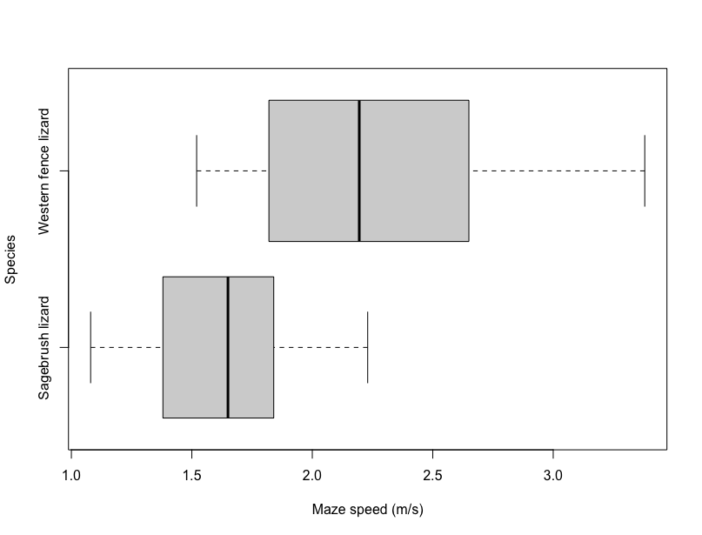

Both species are random samples, and they are independent. The distributions are roughly symmetric and the distance between the median and the quartiles in the boxplot are roughly the same. Hence the conditions to perform a two-sample t test are met.

1. (2 points) Using the sample statistics determined in question 2, calculate the test statistic for the two sample *t* test for the difference in population means.
$$t=\frac{-0.702}{0.134}=-5.239$$

2. (2 points) Using the degrees of freedom from question 5 and the test statistic from the previous question, calculate the p-value. *Hint: sketch the curve and shade in the p-value!*

p = pt(-5.239, 32.582) = 4.718e-06 * 2 = **9.436e-06**

p-value area



1. (2 points) Using the p-value from the previous problem, complete the following p-value interpretation by filling the blanks.   
     
   *The probability of observing a difference in sample means of* ***-0.702*** *or a difference even more extreme is* **9.436e-06***, when the null hypothesis is true.*
2. (4 points) Write a 4-part conclusion to answer the question of interest. Use a $α= 0.1$ significance level.

There is convincing evidence to suggest that the average speeds of the two lizard species are different. We reject the Null Hypothesis that the average speeds of the two lizard species are equal. Note: it is possible we made a Type 1 error.

**Gradescope Page Matching (2 points)**

When you upload your PDF file to Gradescope, you will need to match each question on this assignment to the correct pages. Video instructions for doing this are available in the Start Here module on Canvas on the page “Submitting Assignments in Gradescope”. Failure to follow these instructions will result in a 2-point deduction on your assignment grade. Match this page to outline item “Gradescope Page Matching”.